**Engineering**

**Faculty of**



**School of Electrical, Electronic & Computer Engineering**

**EERI 414**

**PRACTICAL ASSIGNMENT 1: Digital Filter Design**

Completed by:

**Mr J.P. de Lange 23689293**

Submitted to:

 **Prof W. Venter**

25 October 2017

# DECLARATION

I, **Johannes de Lange**, declare that this report is a presentation of my own original work.

Whenever contributions of others are involved, every effort was made to indicate this clearly, with due reference to the literature.

No part of this work has been submitted in the past, or is being submitted, for a degree or examination at any other university or course.

Signed on this, 25th day of October 2017, in Potchefstroom.

J.P. de Lange

**INITIALS AND SURNAMES**

# TABLE OF CONTENTS

DECLARATION ii

TABLE OF CONTENTS iii

LIST OF FIGURES iv

LIST OF TABLES v

1. INTRODUCTION 1

1.1 BACKGROUND 1

1.2 DESIGN REVIEWS 1

2. CALCULATIONS 3

2.1 NORMALIZED ANGULAR FREQUENCIES, PRE-WARPED VALUES AND CONCLUSIONS 3

2.2 LOW-PASS FILTER PROTOTYPE 4

2.3 BILINEAR TRANSFORMATIONS 4

2.4 MINIMUM STOP-BAND ATTENUATION AND PEAK PASS-BAND RIPPLE 5

2.5 TRANSFORMATION INTERMEDIATE CALCULATIONS 5

2.7 TRANSFORMATION TO BAND-STOP FILTER 6

3. REALIZATIONS OF THE TRANSFER FUNCTION 6

3.1 DIRECT FORM 7

3.2 CANONICAL FORM 8

4. RESULTS FROM RESPONSES 8

4.1 DISCRETE 10

4.2 S-DOMAIN 11

4.3 INPUT 11

4.4 REALIZATIONS 13

5. CONCLUSIONS AND RECOMMENDATIONS 16

References 17

# LIST OF FIGURES

Figure 1 : Low-pass filter s-domain, z-domain, and transfer function 5

Figure 2 : Band-stop filter s-domain, z-domain, and transfer function 6

Figure 3 : Type 2 direct form filter realization scheme 7

Figure 4 : Canonical form filter realization scheme 8

Figure 5 : Scope output of MATLAB generated signals 9

Figure 6 : Spectrum analysis scope output for combined signals 9

Figure 7 : Discrete filter transfer function 10

Figure 8 : S-Domain filter transfer function 11

Figure 9 : Original Input Signal 11

Figure 10 : Input Signal FFT 12

Figure 11 : Direct form type 2 output signal 13

Figure 12 : Direct form type 2 FFT output 14

Figure 13 : Canonical form output signal 14

Figure 14 : Canonical form FFT output 15

# 

# LIST OF TABLES

Table 1 : List of Abbreviations v

Table 2 : Filter specifications as per the assignment 1

Table 3 : Cropped calculations for step 1 3

Table 4 : Component calculation equations 4

Table 1 : List of Abbreviations

|  |  |
| --- | --- |
| **Abbreviation or Symbol** | **Meaning** |
| IDE | Integrated Development Environment |
| FFT | Fast Fourier Transform |
|  |  |

## INTRODUCTION

### BACKGROUND

Digital filter design is a method that has seen the perfection and optimisation of algorithms approximately 30 years prior to date, that leaves a would-be designer with various libraries and options to complete such a task. This report explains the digital design of a band-stop filter without the help of programs such as MATLAB, Python, Ruby, etc. to implement the filter.

The IDE chosen was Visual Studio 2017 Community Edition, with the help of some visualisation and plotting libraries, to perform realizations. First a prototype low-pass filter must be designed, transformed to the s-domain, converted to the z-domain, then obtain a transfer function, use bilinear transformation to convert it to a band-stop prototype, and finally implement that filter by using the specifications given in the assignment.

### DESIGN REVIEWS

#### SPECIFICATIONS FOR FILTER

The following table denotes the specifications for the filter design to adhere to:

Table 2 : Filter specifications as per the assignment

|  |  |  |  |
| --- | --- | --- | --- |
| **DESCRIPTION** | **SYMBOL** | **VALUE** | **UNIT** |
| Sample rate |  | 9 | kHz |
| Passband Upper Edge |  | 4,2 | kHz |
| Passband Lower Edge |  | 0,19 | kHz |
| Stopband Upper Edge |  | 3,3 | kHz |
| Stopband Lower Edge |  | 2,5 | kHz |
| Peak Passband Ripple |  | 1,2 | dB |
| Minimum Stopband Attenuation |  | 35 | dB |

#### FLTER DESIGN APPROACH

Following the guidelines set out in the prescribed textbook as referenced in section 9.4 of [1], we obtain the steps shown below in the effective design and prototyping of a digital filter:

1. Perform a pre-warp on the specified digital frequencies to obtain the analogue filter frequency specifications.
2. Convert the obtained frequencies to that of a prototype analogue low-pass filter.
3. Using the appropriated methods, design the analogue low-pass filter.
4. Transform the transfer function of the prototype to that of the desired filter type using the transformation equations from Table 9.1 of [1].
5. Using bilinear transformation, convert the transfer function from the s-domain to the z-domain.

## CALCULATIONS

The calculations for this specific type of filter are greatly discussed in our prescribed textbook, thus intermediate calculations will not be shown, and only the starting equation and the result.

### 2.1 NORMALIZED ANGULAR FREQUENCIES, PRE-WARPED VALUES AND CONCLUSIONS

The equation used to normalise the angular frequencies is:

And for pre-warping:

,

Delivering these results as in the table below:

Table 3 : Cropped calculations for step 1

|  |  |  |  |  |  |
| --- | --- | --- | --- | --- | --- |
|  |  | **ANGULAR FREQUENCY** | | **PRE-WARPED** | |
| **DIGITAL FREQUENCY (kHz)** | **->** | **SYMBOL** | **VALUE (rad/s) (*pi)** | **SYMBOL** | **VALUE** |
| 0,19 |  | 0,0422 |  | 0,0664 |
| 2,5 |  | 0,5556 |  | 1,1919 |
| 3,3 |  | 0,7333 |  | 2,2457 |
| 4,2 |  | 0,9333 |  | 9,5096 |

The stop-band bandwidth is calculated as:

The square centre frequency as:

The pass-band edge product:

### 2.2 LOW-PASS FILTER PROTOTYPE

For the case of band-pass or band-stop filters, the bandwidth must remain constant, and for band-stop filters, the passband frequencies must then be adjusted to produce geometrical symmetry around , to this end we will modify the lower passband frequency to become . we will also set the lower stop-band frequency to 1 for the prototype leaving us finally with the passband edge frequency calculation for the low-pass prototype filter as:

### 2.3 BILINEAR TRANSFORMATIONS

For our bilinear transformation we will need to obtain the answers of a few intermediate equations before starting the main transformation, only the equations will be added here to save time as they are implemented in the application code.

Table 4 : Component calculation equations

|  |  |  |
| --- | --- | --- |
| **COMPONENT** | **EQUATION** | **EQ** |
| Epsilon |  | A.8a [1] |
| Bilinear transformation equation |  |  |
|  |  | A.28c |
|  |  | A.28b |
|  |  | A.28a |
|  |  | A.27 |
| Square-magnitude response |  | A.26 |

### 2.4 MINIMUM STOP-BAND ATTENUATION AND PEAK PASS-BAND RIPPLE

The following two equations yield the minimum stop-band attenuation and the peak pass-band ripple respectively:

### 2.5 TRANSFORMATION INTERMEDIATE CALCULATIONS

Now we need to calculate the centre frequency:

To determine the order (N), we require the transition speed for the transfer function which is calculated as such:

Using the discrimination factor and the selectivity factor for this calculation, we can find the minimum order to be , with a recommended order of according to equation A.25 in [1] and software.

And this yields the values needed to compute the prototyping equation:

Which will apply to a model such as the figure below:

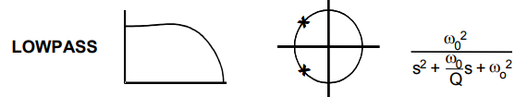

Figure 1 : Low-pass filter s-domain, z-domain, and transfer function

### 2.7 TRANSFORMATION TO BAND-STOP FILTER

By applying equation (B3-B7) we obtain the following band-stop transfer function:

* s-domain:
* z-domain after applying the bilinear transform as in Table 4:

This function should yield outputs similar to the ones shown below:

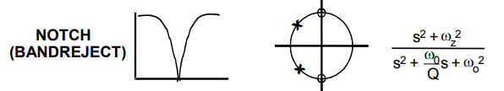

Figure 2 : Band-stop filter s-domain, z-domain, and transfer function

## REALIZATIONS OF THE TRANSFER FUNCTION

The realizations obtained from the z-domain function in section 2.7 can be depicted in numerous ways, due to the mathematical constraints and or difficulty of factorisation, the type 2 direct form, and the canonical form realizations have been selected.

### 3.1 DIRECT FORM

The equation for the direct form is as follows:

And here follows the graphical depiction of the filter:

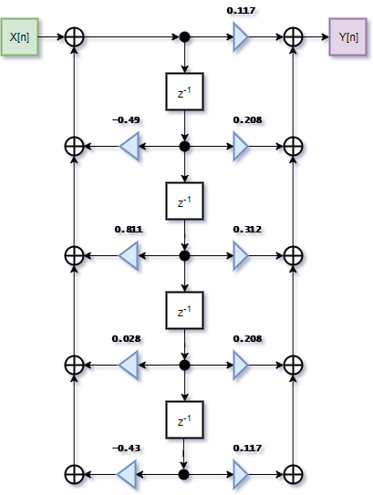

Figure 3 : Type 2 direct form filter realization scheme

### 3.2 CANONICAL FORM

The equation for the canonical form is as follows:

And here follows the graphical depiction of the filter:

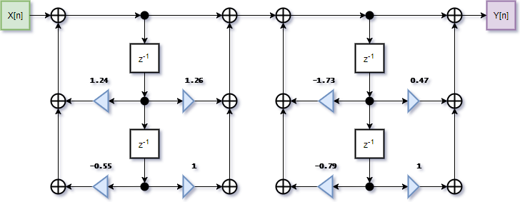

Figure 4 : Canonical form filter realization scheme

## RESULTS FROM RESPONSES

The input signal was constructed using Simulink, which is part of the MATLAB package. The model shown below merely generates the following set of frequencies: 100, 500, 1500, 2800, and 4500Hz. The model is shown below:

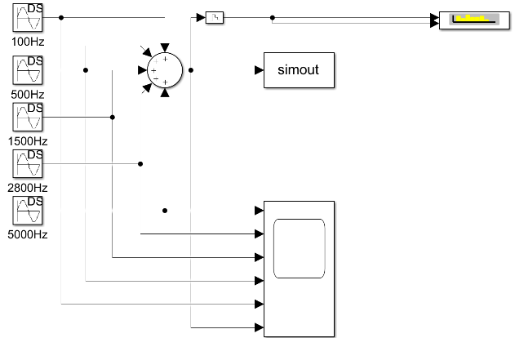

The signal generated by the model is then displayed using a nested scope output, a spectrum analysis scope, and the generated array of values for the combined signals was output as a single array and then copy pasted as a variable into the Visual Studio 2017 EERI414DSP software that was being developed. The outputs of the two different scopes are also shown below:

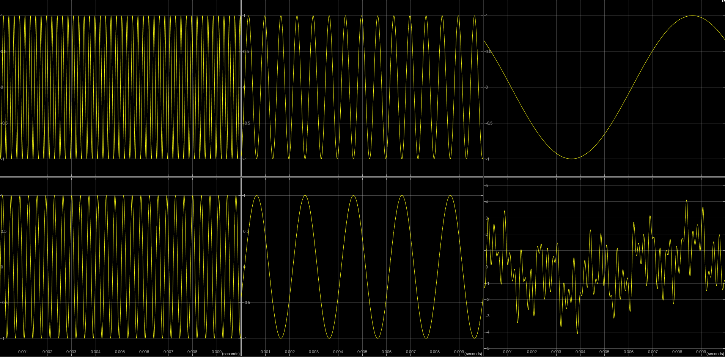

Figure 5 : Scope output of MATLAB generated signals

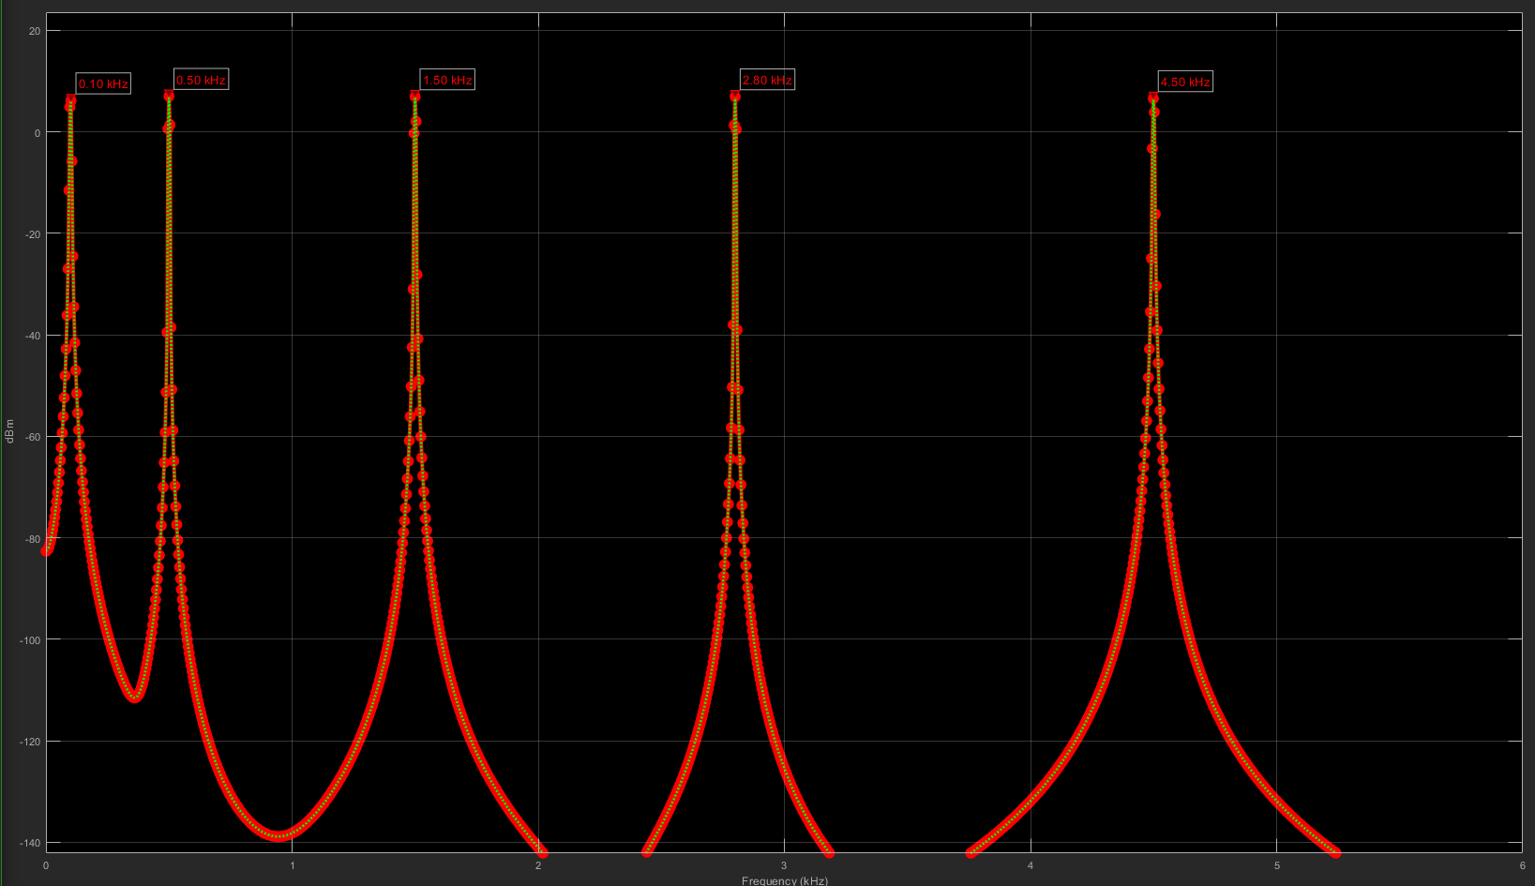

Figure 6 : Spectrum analysis scope output for combined signals

As seen in the figures above the five sinusoidal waves are summed into a single signal, the spectrum analysis shows the peak frequencies at the desired points as reported above.

### 4.1 DISCRETE

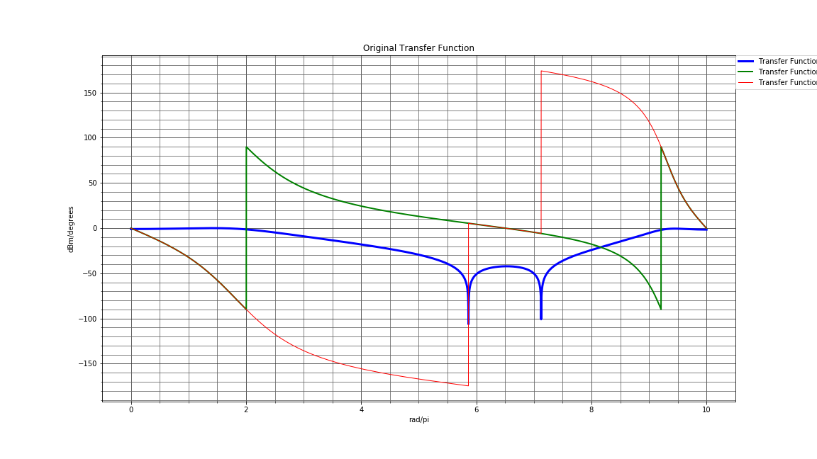

Figure 7 : Discrete filter transfer function

The discrete filter transfer function displays a normalised frequency range, where the blue line is the filter transfer function magnitude in dBm, the green line displays the phase shift in degrees, whereas the red line is the unwrapped phase shift also in degrees. This colour coding holds true for the S-Domain transfer function in the next section also. In both figures the flattened phase response where the band-stop is active, this is a clear indication that the filter is functional in both cases. The S-domain (analogue) shows off the filter function at a time-based level and although there is a misnamed x-axis (should also be rad/pi) the band-stop filter distinctive shape is still very recognisable. It is important to note that at this stage it is possible to see plainly the -35dB stop band value, and the 1.2dB pass band ripple, if only just barely due to the difficulties of graphic plotting in C++ using Visual Studio 2017.

### 4.2 S-DOMAIN

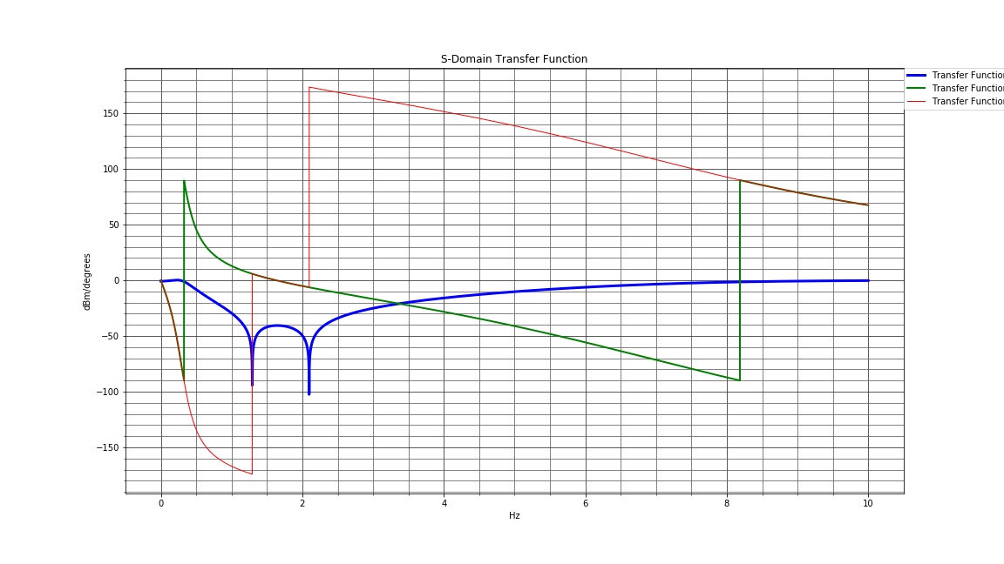

Figure 8 : S-Domain filter transfer function

### 4.3 INPUT

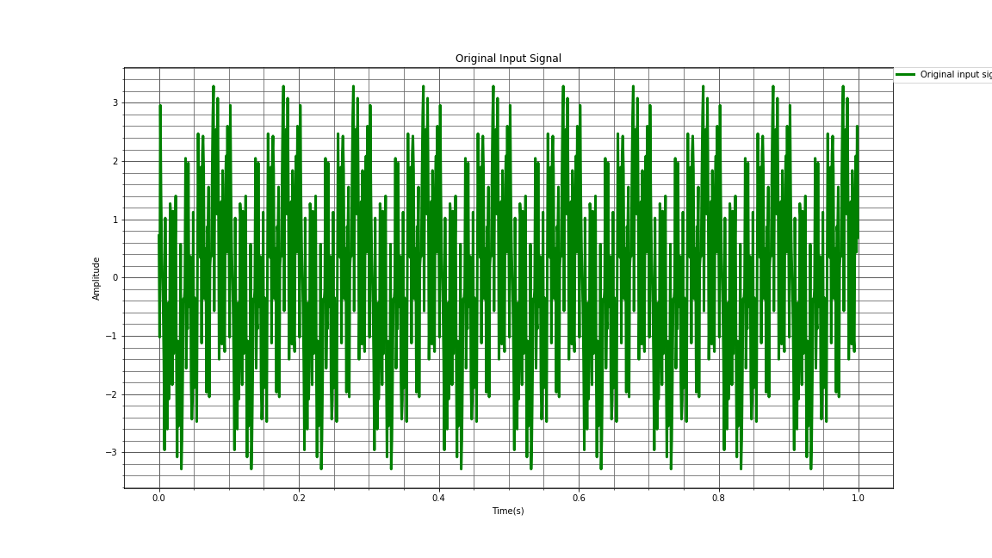

Figure 9 : Original Input Signal

The original input signal above contains 1000 sample points of data to display the signal above, when compared to the MATLAB generated signal containing only a tenth of the time spa, or a single full period, it is clear to see the coherence to the original shape, the FFT of the signal shown below is not as aesthetically pleasing as the MATLAB version, but still displays the peaks at the generated frequencies, 100, 500, 1500, 2800, and 4500Hz respectively. This shows that the datum-line or control group of the practical is functional and accurate, although somewhat aesthetically displeasing.

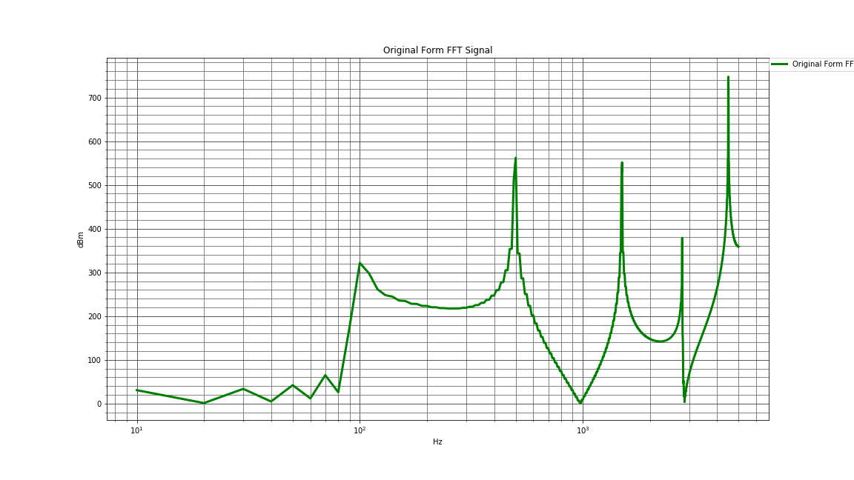

Figure 10 : Input Signal FFT

Having the control group of the project verified, we can now move on to our two selected filter realizations namely the Direct form type 2 realization, and the Canonical or cascaded form realization. These specific types were chosen to show the difference in responses that they both achieve, and since not much needs to be changed from the original transfer function to obtain their specific designs.

### 4.4 REALIZATIONS

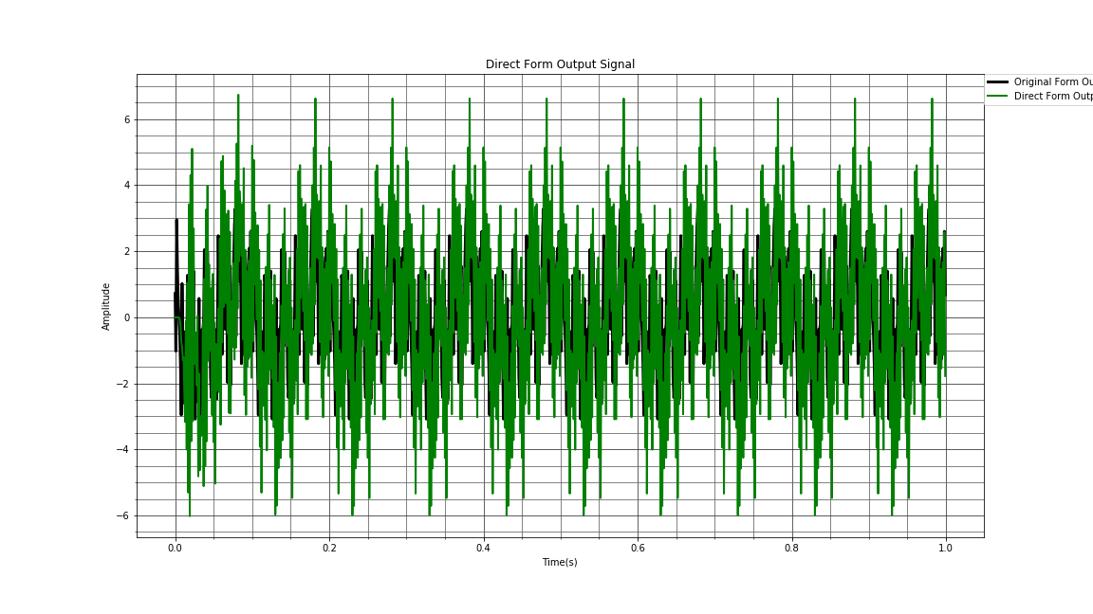

Figure 11 : Direct form type 2 output signal

The output signal from the direct form in green is compared to the original signal in black, this shows the clear difference in signals as certain frequency components have now been removed from the original input. Below we can view the FFT of the direct form type 2 output signal, and we can now note that a few important details arise here. First off, the frequencies not within the band-stop range are: 100, 500, 1500, and 4500Hz, thus a single frequency component at 2800Hz had to be removed in both the direct form and canonical form outputs. As visible although not extremely prominently in the FFT output shown below, the peaks of the FFT output show the clear presence of the 100, 500, and 4500Hz components, and a visibly flattened (-35dB) 2800Hz component. This correlates to the original input values and supply us with the desired effect concerning the filtering of the input signal. An unfortunate by-product here is that the 1500Hz component has also suffered, it is unclear in the figure below if this is due to faulty values or the crooked FFT display.

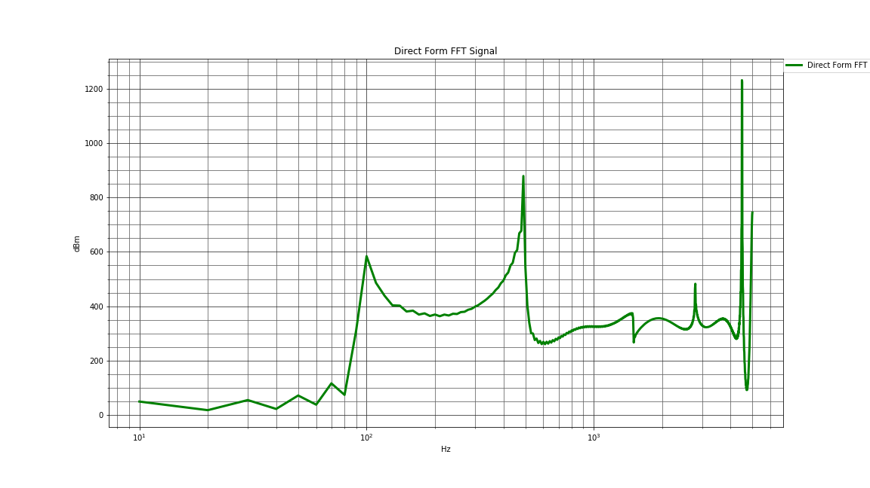

Figure 12 : Direct form type 2 FFT output

The FFT figure above also shows a spike at 5000Hz, this is mainly since not enough sample points could be used for this complexity of a signal, and this erroneous spike is unfortunately the outcome of sample mismatching.

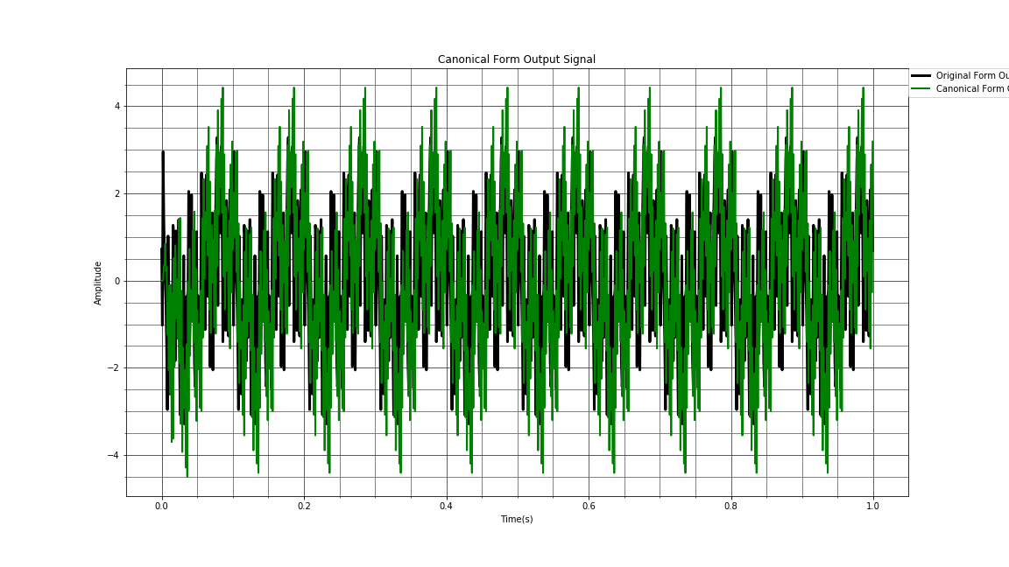

Figure 13 : Canonical form output signal

In the signal shown above, the comparison between the original input signal and the normalised canonical output signal is seen, where original input is again the black line, and the canonical form output is the green line. Here we can again see from the signals that certain frequency components have been removed, and FFT is required to show exactly which, thus the image below. In the canonical form signal output FFT figure below we can again see the strong presence of the 100, 500, and 4500Hz components, in this form the 1500Hz component is also still quite visible, but the 2800Hz component is flattened out completely. A possible reason for the malformed FFT output is the sample output rate from the filter realisations not containing enough data for a higher resolution outcome.

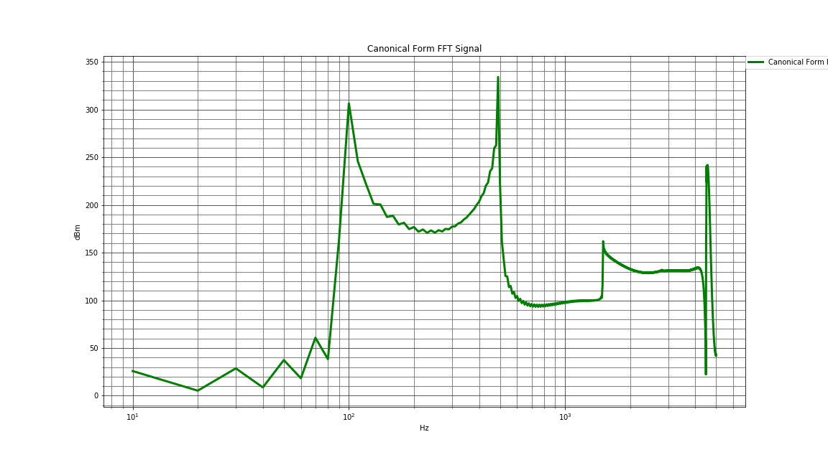

Figure 14 : Canonical form FFT output

## CONCLUSIONS AND RECOMMENDATIONS

In conclusion it will suffice to say that the filter design was a success, even though the graphical display of the realisations had some glitches in their outcomes. The fact that the correct frequencies are attenuated by the digital filters proves that the filter design was successful.

The recommendations for this project is that the samples used to produce the outputs for the graphical displays be increased dramatically to ensure a higher resolution output at the FFT stages, this will produce better graphical outcomes and more prominent conclusions to be drawn.

# References

[1] S. Mitra, Digital signal processing. New York, NY: McGraw-Hill, 2011